

Travlr Getaways Website Design Application

CS 465 Project Software Design Document
Version 2.0

Table of Contents

CS 465 Project Software Design Document 1
Table of Contents 2
Document Revision History 2
Instructions 2
Executive Summary 3
Design Constraints 3
System Architecture View 3
Component Diagram 3
Sequence Diagram 4
Class Diagram 4
API Endpoints 4
The User Interface 4

Document Revision History

Version | Date | Author | Comments
1.0 | 09/24/2025 | K. Oti Amponsah | Adding Executive Summary, Design Constraints and System Architecture View (Component diagram)
1.1 | 10/3/2025 | K. Oti Amponsah | Adding Sequence and Class diagrams to the System Architecture View and API Endpoints
1.2 | 10/14/2025 | K. Oti Amponsah | The User Interface updated
2.0 | 10/24/2025 | K. Oti Amponsah | Document completed and submitted

Executive Summary

Travlr Getaways is a trip planning service that allows customers to form an account, browse for packages by location and price, and make bookings for future travels. The application's customer-facing side enables easy search and booking of trip packages. The Single Page Application (SPA) enables administrators to manage user authorization and control the website. This two-pronged strategy makes sure that both customers and administrators have a smooth experience.
The Travlr Getaways website uses MEAN stack technology, including MongoDB, Express, Angular, and Node.js. The project establishes the groundwork for complete CRUD operations and interaction with MongoDB in later stages of development by utilizing modular Express routes and controllers to structure the server and adding dynamic content with Handlebars.

Design Constraints

The creation of the Travlr Getaways online application is guided by a number of design restrictions that has to do with Security, Scalability, Browser compatibility, Data storage and Stack limitations
- Security: Strong encryption and authentication techniques are required in order to ensure that user data, including payment information, is kept and sent in a safe manner.
- Scalability: It is necessary for the program to be able to manage thousands of concurrent users, which necessitates database queries that are efficient and server performance that is optimized.
- Browser compatibility: The software must work with all the major browsers out there. Limitations on advanced feature usage may result from designing and testing for various browsers.
- Data Storage: File-based data storage will eventually give way to MongoDB to enable concurrent access and durable data.
- Stack Limitations: It is possible that MongoDB places restrictions on some transactions. A single document can be no larger than 16 megabytes when using MongoDB. As time passes, cloud services have the potential to become expensive.

System Architecture View

Component Diagram
The Representational State Transfer application program interface, or REST API, connects the client, server, and database and enables communication between the three components. Every piece of data in these components makes use of a set of URLs that, when accessed, return certain data.

The Client component is the Front-End and is the Angular in MEAN. In order to show the web browser and store the components of the traveler portfolio, the client connects to both the server and the database. The client component is granted the ability to show the data as a result of the components of the Graphics Library. The web browser component allows for the management of all aspects of the program, including logic, data processing, user flow, and template delivery.

The Node.js and Express frameworks are both included in MEAN, which makes up the application server and is referred to as the Server component. All of the software required to create web applications and to construct the web server is contained in the .js files. Using JavaScript, the .js files are used to generate the Traveler Database. After then, Express configures the server on the web to listen for requests that are coming in and to return responses that are relevant. A straightforward mechanism for routing incoming URLs to a particular piece of code is provided by Express. In general, the server is responsible for verifying the identities of users and managing communication between MongoDBs. The Mongoose ODM component is a component that structures the server data.

The physical server is home to the database component, which has the capability to store and use data for applications. JSON is used to store documents such as the photographs and descriptions of vacation packages. Both the client and server components have the ability to be served the documents that are saved in MongoDB.

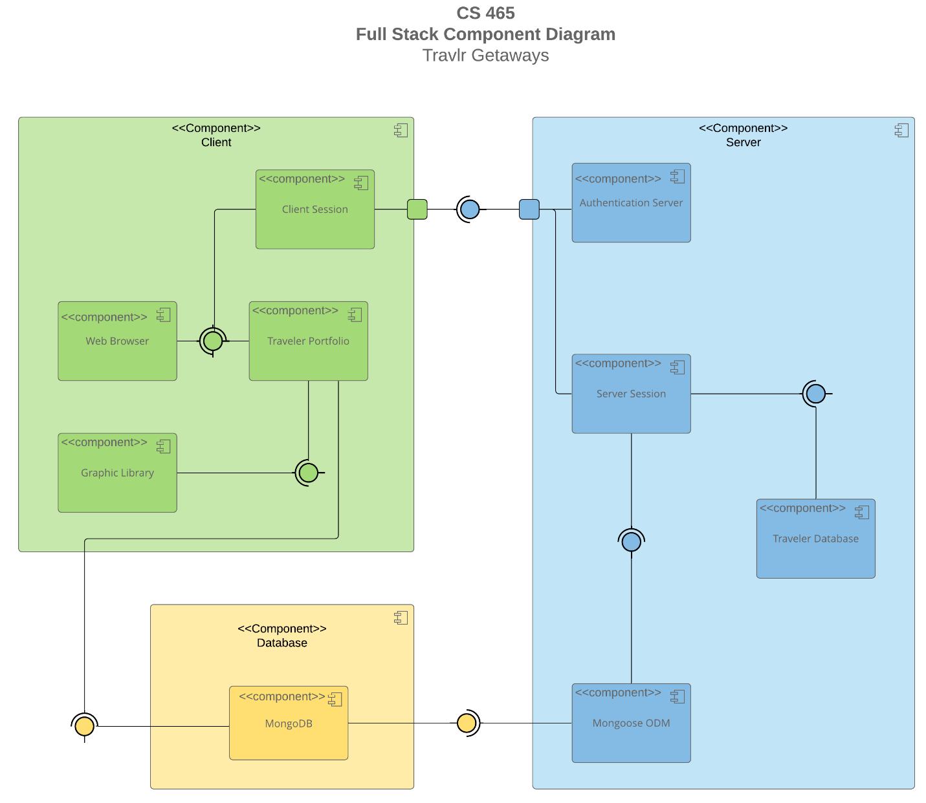

Sequence Diagram

The three most important components are depicted in the diagram that is located below: the client, the database, and the server. When we have finished with the user's PC, we can then on to discussing the view. When the user logged in, they would be granted access. After that, the server side would make a call to the website by utilizing MongoDB, and it would finally establish a connection with the Traveler website. Following this, a view is displayed and a scope is assigned to the situation. Once the data has been collected, the HTTP will be sent to the user.

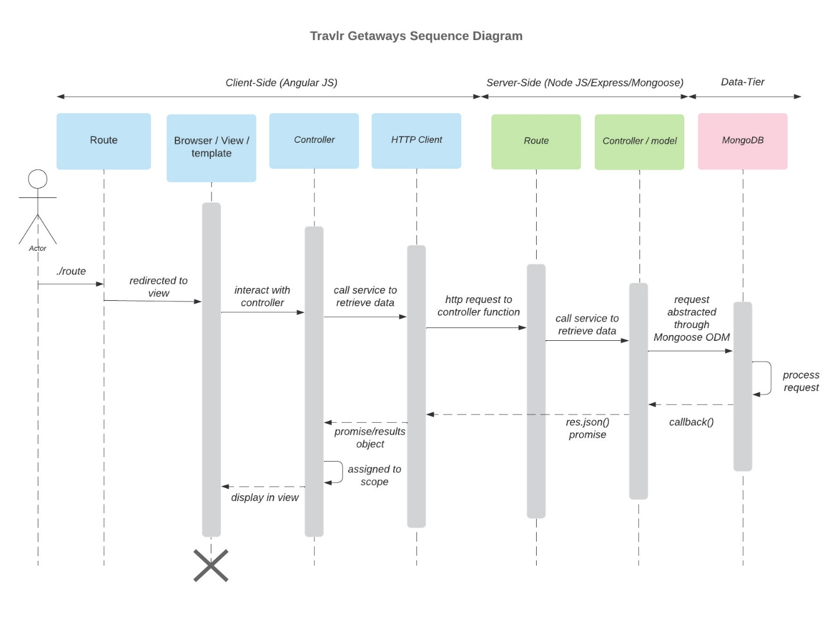

Class Diagram

We are able to see the various connections that exist between the classes thanks to the class diagram. Every user will begin with a regular account, but they will have the opportunity to advance their positions and take on more responsibilities inside the platform. If we take travel agents as an example, they would be considered the usual account role. It would be possible for the travel agents to use the itinerary to become familiar with the many items and to engage with each of them.
The information that pertains to FlightInfo, CruiseInfo, and HotelInfo is kept within the TravellerInfo database. After that, the data will interact with the website, and the website will display information about the site to the user whenever the user is interacting with the website.
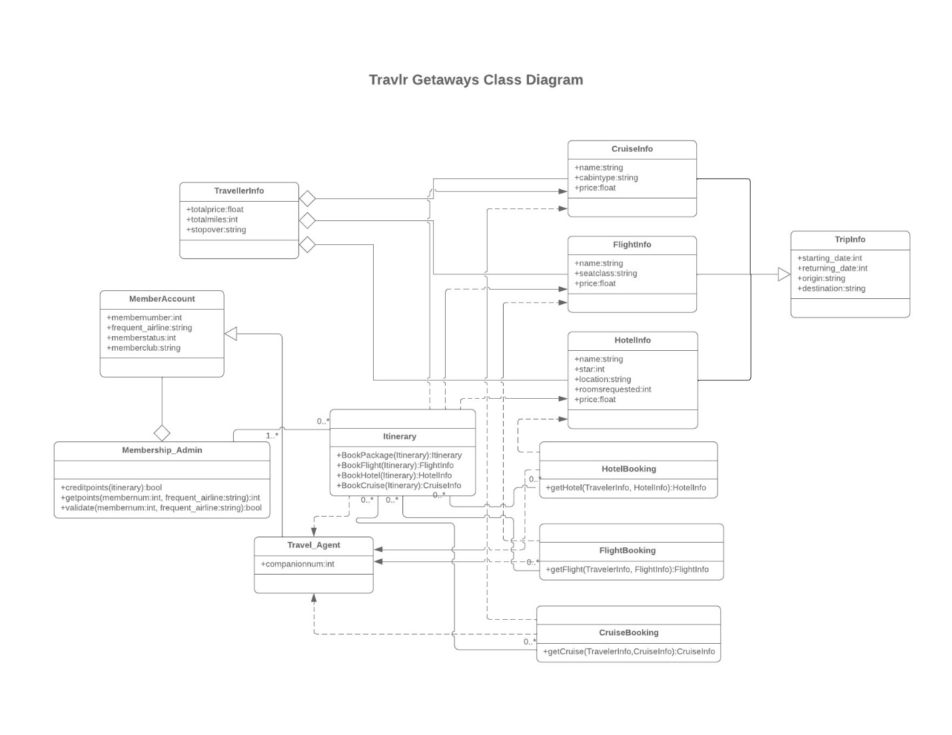

API Endpoints

Method | Purpose | URL | Notes
GET | Retrieve one trip by code | /api/trip/: tripcode | Returns a single trip object from the database using the tripcode as reference  for which trip to retrieve
GET | Retrieve all trips | /api/trips | Returns all trips from the database
POST | Adding a trip to the database | /api/trips | Adds a trip to the database
PUT | Update a single trip in the database | /api/trip/:tripcode | Updates a single trip object using inputs from an html form in Angular application
DELETE | Delete a single trip in a database | /api/trip/:tripcode | Takes a trip code and  deletes that trip
POST | Register a new user | /api/register | Takes a name, email, and password and registers a user by placing them in the database after hashing the password
POST | Login a user | /api/login | Takes an email and  password to login a user, returns a jwt

The User Interface

User login page
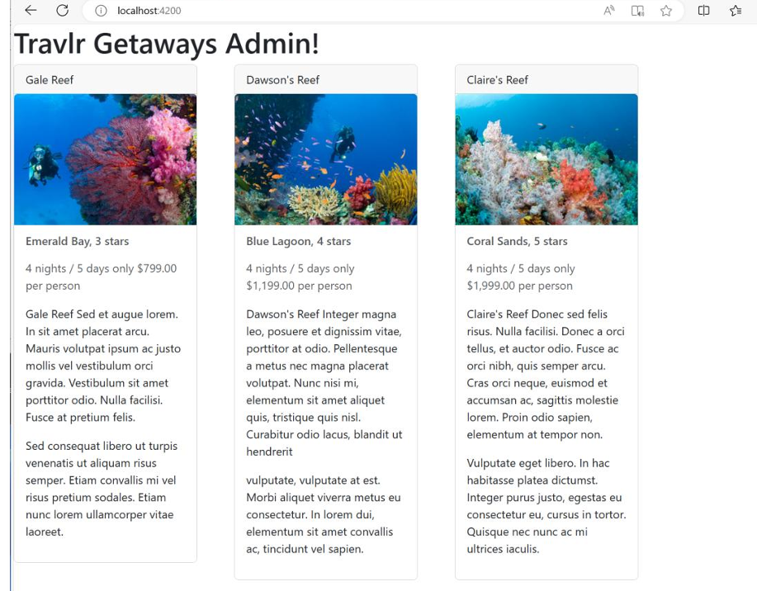

Logged in page
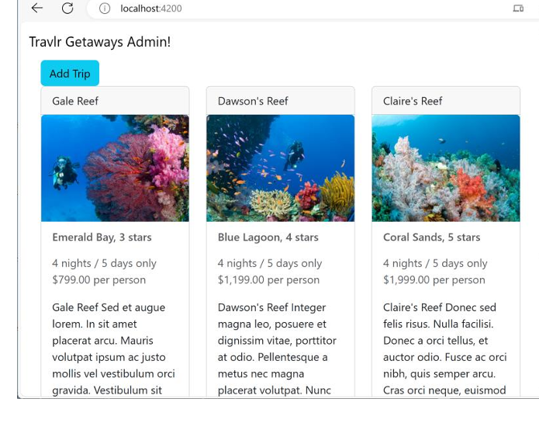

Summary of the Angular Project and the SPA

Accessing and displaying Trip information onto a single-page application for logged-in administrative users is accomplished by the backend application using Angularjs, node.js, and MongoDB. For the sake of clarity, we shall summarize the project here due to the application's enormous complexity.
A user may get all the information they need from a single web page thanks to the Angular application. To achieve this, Angular makes use of components, which are essentially little application sections. These components may be put into any section of the application's HTML code and used to display the page. With Angular routing, a service is used to link all the components together. Components make service calls, which are redirected to the API based on the kind of call (PUT, POST, GET, etc.). In contrast to Express applications, which necessitate separate HTML and routing for each page, Angular SPAs allow for the management of numerous components via a single service. Because of this, all SPA pages may swiftly get the data they need.

Dropdown menus, navigation bars, and interactive buttons are just a few of the numerous third-party components that Angular can work with. One such component is (you guessed it!) Bootstrap. Because Angular's components may be attached to each other, the framework enables a modular structure that lets developers build interactive web pages fast and easily without having to copy and paste code. Refactoring code is also made considerably easier by this.
First things first when testing an application like this: make sure the API routing is working. To accomplish this, we utilize Postman to swiftly inspect all HTTP queries made to the API, such as those for logging in and getting database data. An ordinary web browser with the developer tools enabled can be used to test the application after the routes have been set up. While the app is running, you should look for a number of failures and make sure that all possible problem areas (mostly connections to the backend) are tested. The use of "console.log()" and ".json({"message":" "})" is highly useful in identifying the reason of an error or bug in Angular due to its javascript foundation. Visual Studio also has debugging capabilities with the help of third-party addons.

